Pyrrhic

🔹 What is Pyrrhic
# Source: Chatgpt (GPT-4-turbo) at [8/3/2025]
A pyrrhic (also called a dibrach) is a metrical foot made up of two unstressed syllables:
◡ ◡
It produces a light, quick, and subtle rhythm, often used to soften or de-emphasize certain parts of a line.

✅ Syllable Pattern:
# Source: Chatgpt (GPT-4-turbo) at [8/3/2025]

Position | Stress
1st | Unstressed (◡)
2nd | Unstressed (◡)

✅ Examples of Pyrrhic Phrases:
# Source: Chatgpt (GPT-4-turbo) at [8/3/2025]
- in a
- to the
- of the
- and a
These are typically function words that naturally carry little stress in speech.

✅ Function in Poetry:
# Source: Chatgpt (GPT-4-turbo) at [8/3/2025]
- Rarely used as a dominant meter—too rhythmically weak for an entire line.
- Often appears as a metrical substitution within stronger meters like iambic or dactylic lines.
- Provides contrast to more heavily stressed feet (like spondees), often in tandem with them.

✅ Example of Pyrrhic Substitution:
# Source: Chatgpt (GPT-4-turbo) at [8/3/2025]
From Tennyson's "In Memoriam":
When the blood creeps and the nerves prick
Possible scanning:
When the (◡ ◡) / blood creeps (— —) / and the (◡ ◡) / nerves prick (— —)
Here, "When the" and "and the" are pyrrhics; they contrast with the spondees that follow.

✅ Contrast with Other Metrical Feet:
# Source: Chatgpt (GPT-4-turbo) at [8/3/2025]
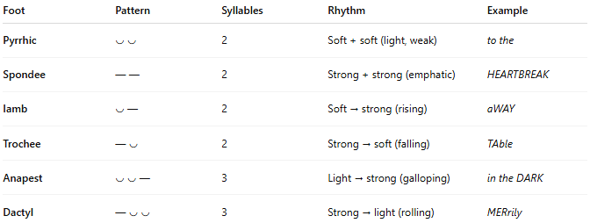
Foot | Pattern | Syllables | Rhythm | Example
Pyrrhic | ◡ ◡ | 2 | Soft + soft (light, weak) | to the
Spondee | — — | 2 | Strong + strong (emphatic) | HEARTBREAK
Iamb | ◡ — | 2 | Soft → strong (rising) | aWAY
Trochee | — ◡ | 2 | Strong → soft (falling) | TAble
Anapest | ◡ ◡ — | 3 | Light → strong (galloping) | in the DARK
Dactyl | — ◡ ◡ | 3 | Strong → light (rolling) | MERrily

📝 Summary:
# Source: Chatgpt (GPT-4-turbo) at [8/3/2025]
- Pyrrhic = two unstressed syllables (◡ ◡)
- Creates soft, subtle rhythm
- Used as a metrical variation, rarely alone
- Often appears with spondees to create contrast

